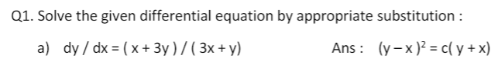

1/ Find the substitution, integrating both sides

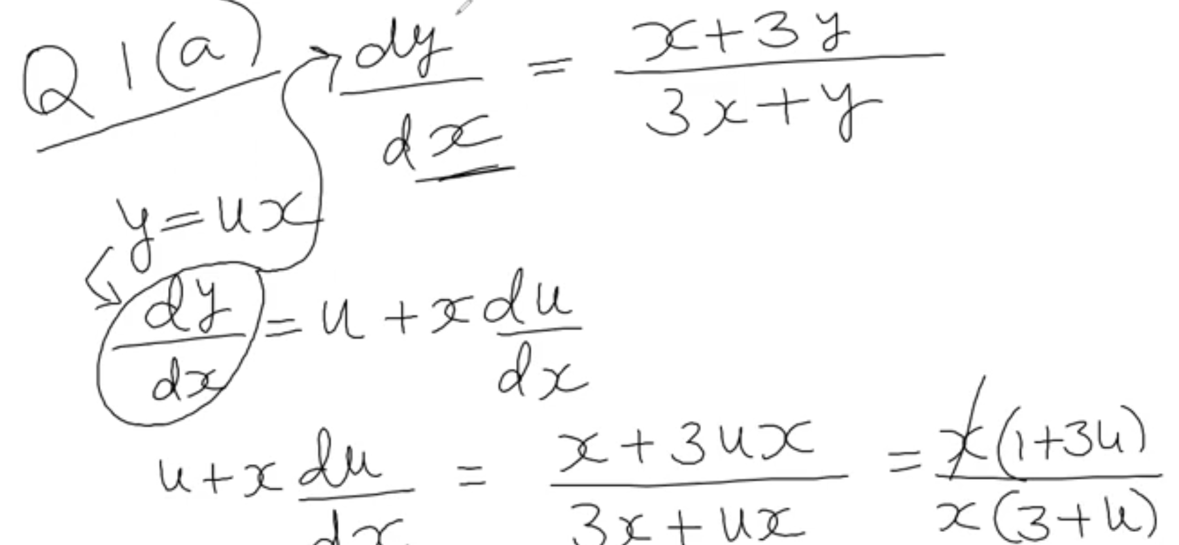

2/ Simplify and separate each variable

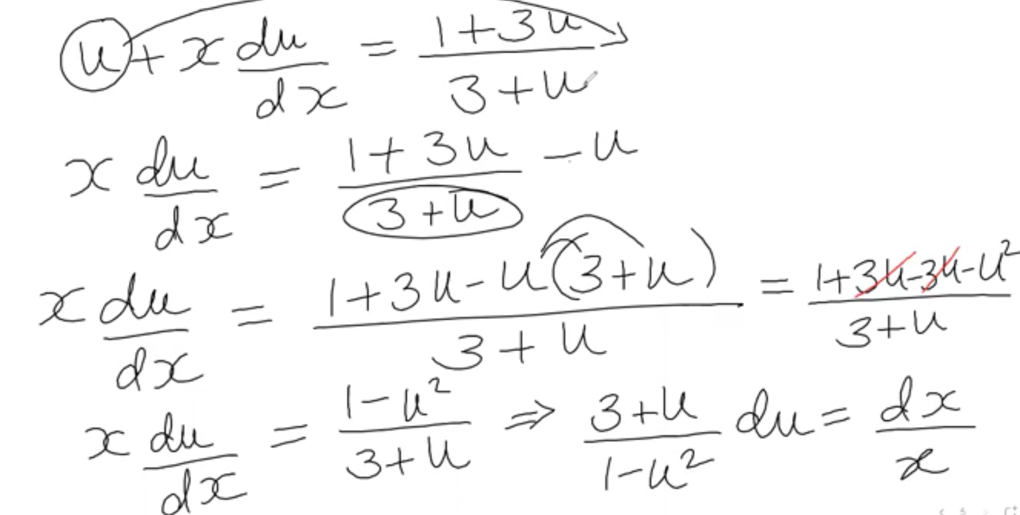

3/ Keep solving

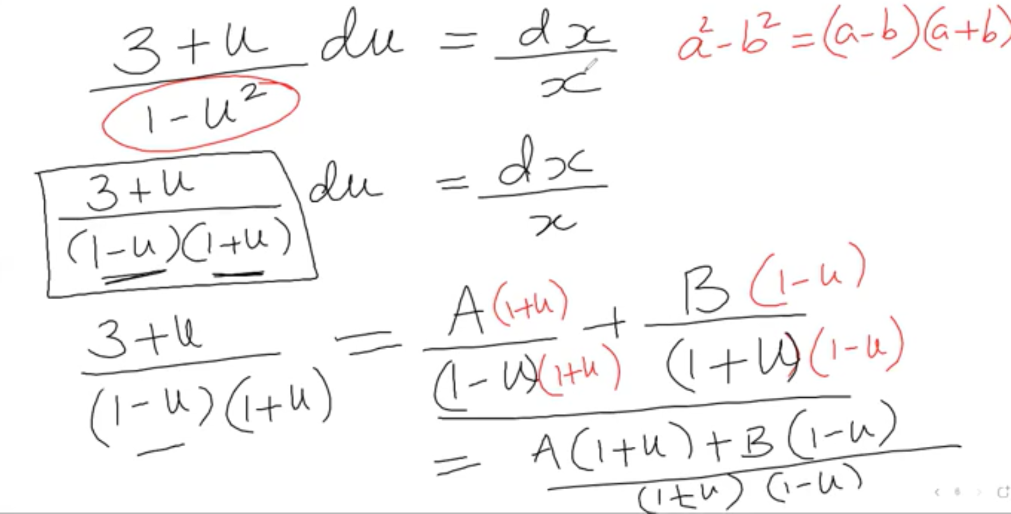

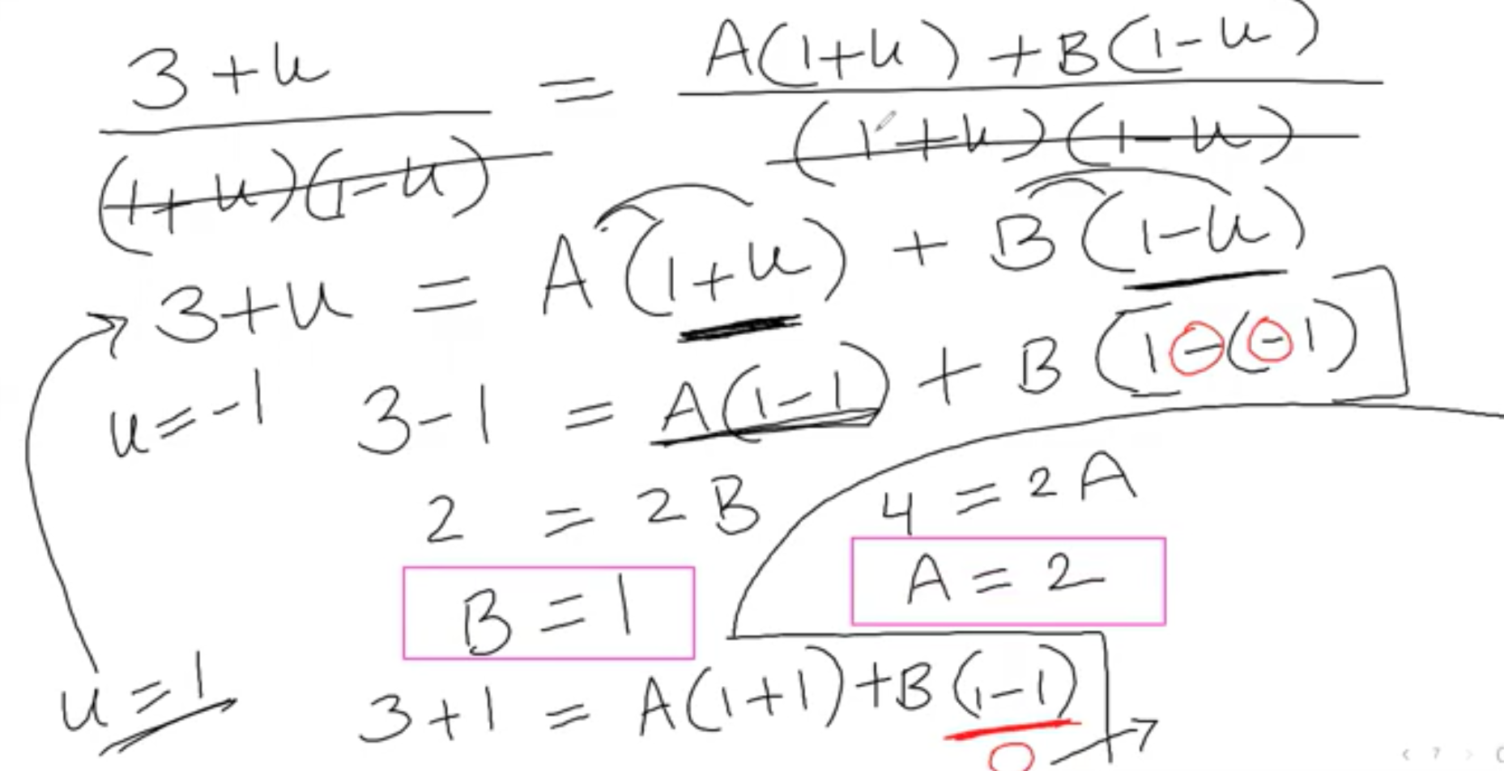

4/ Plug the value of A and B into the substitute equation. Then integrating both sides of the separable function

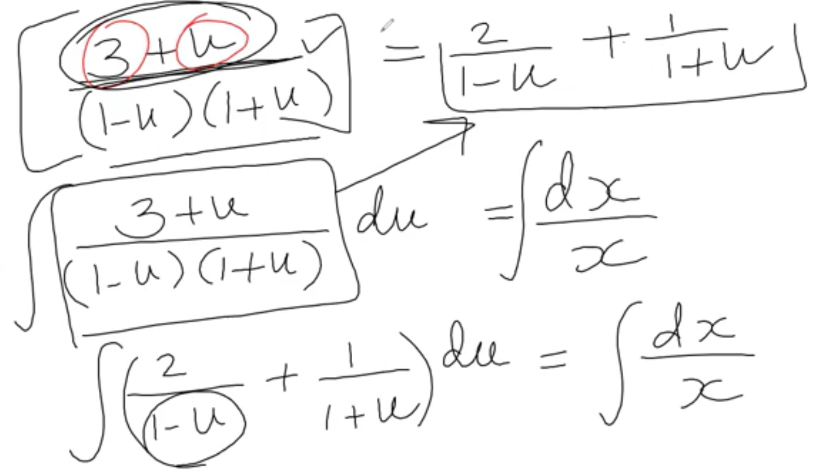

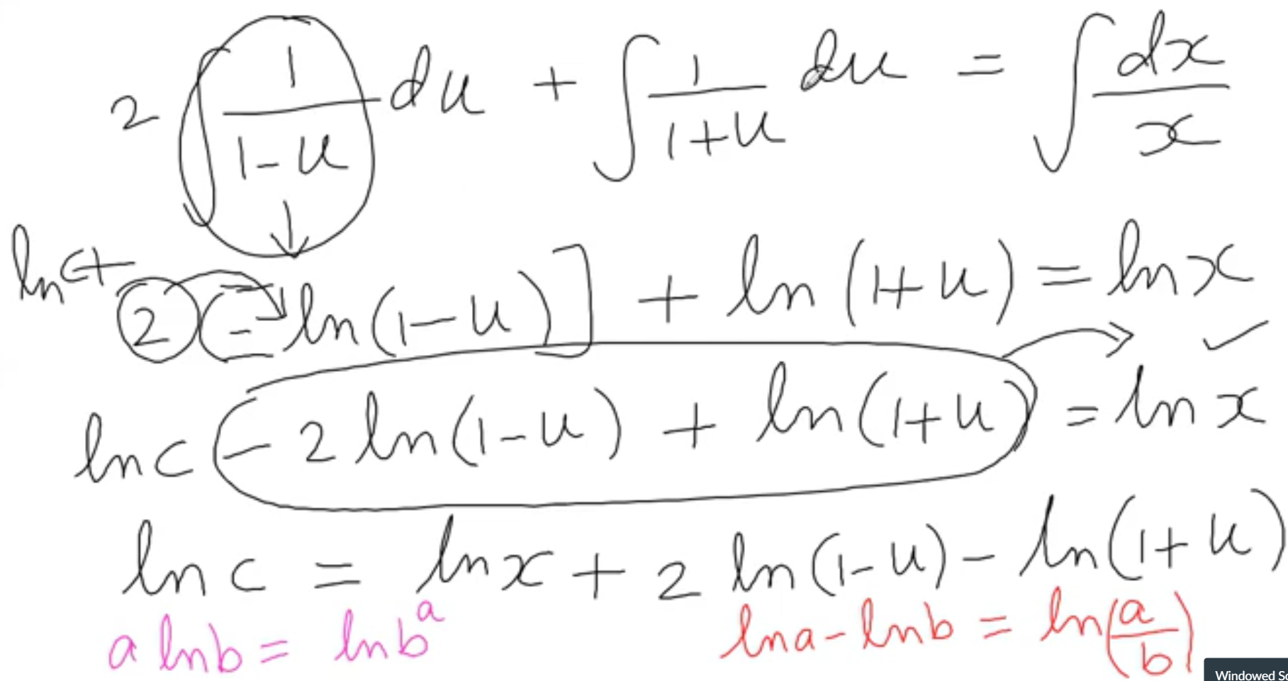

5/ Use the substitute function to find u and plug in the function on Step 4

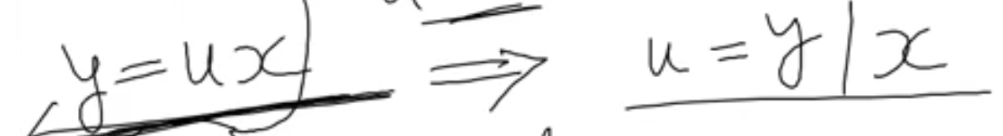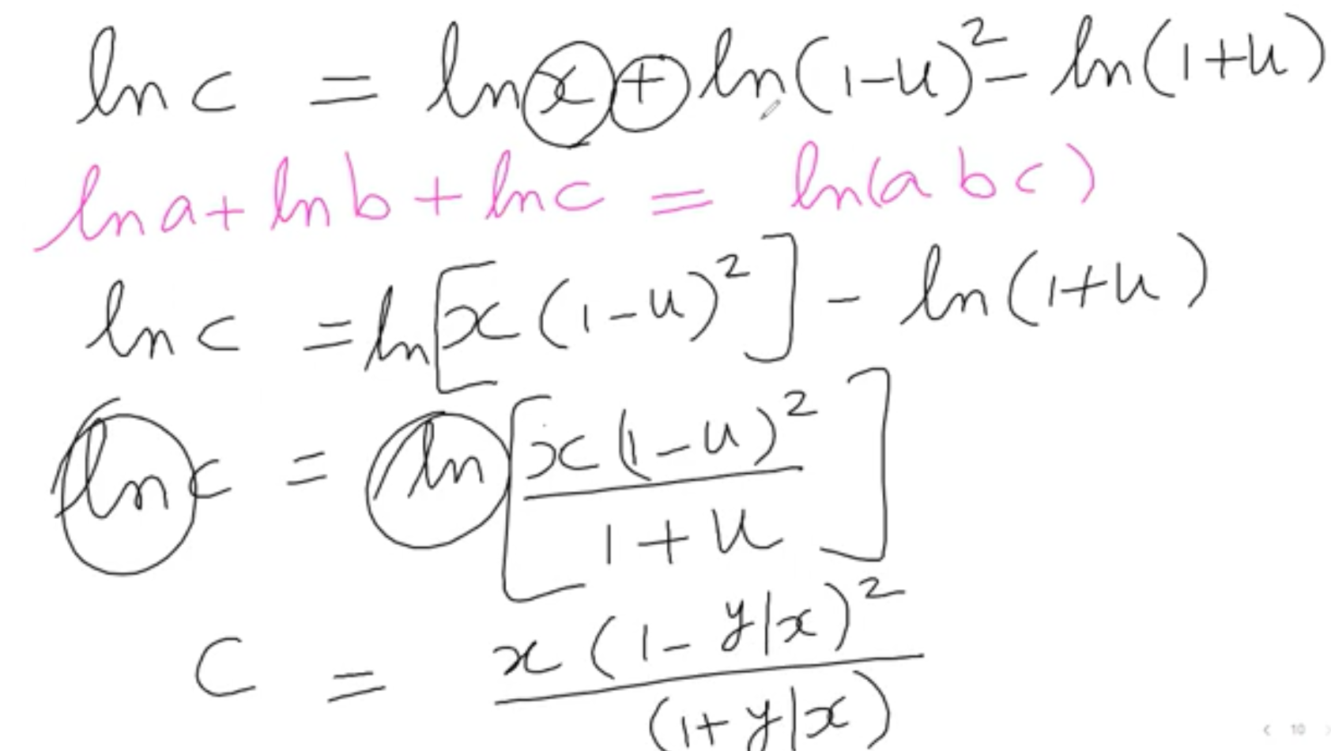

6/ Simply find the function to find c or function y

Can’t find the y because we can’t separate the x,y in this case

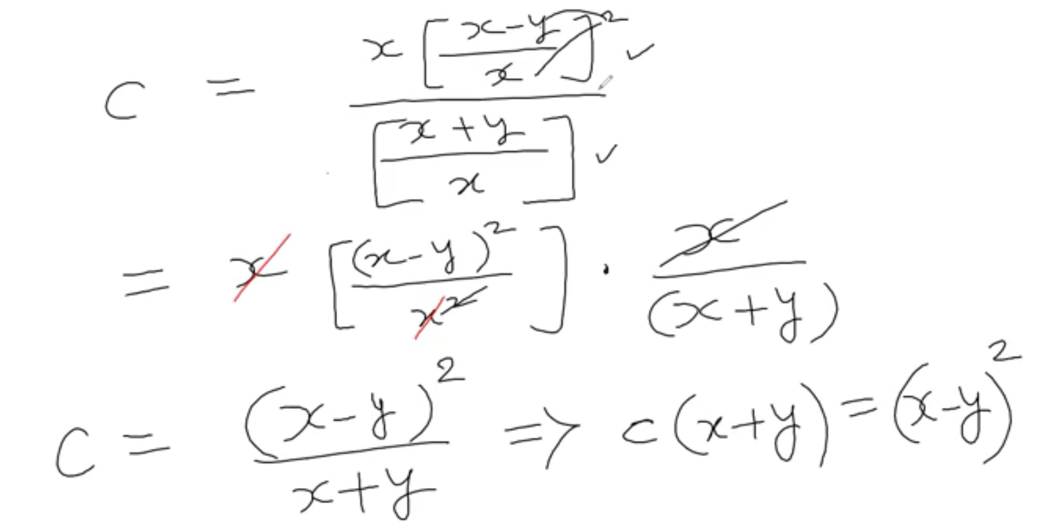



1/ find the substitute and integrating with respect to x

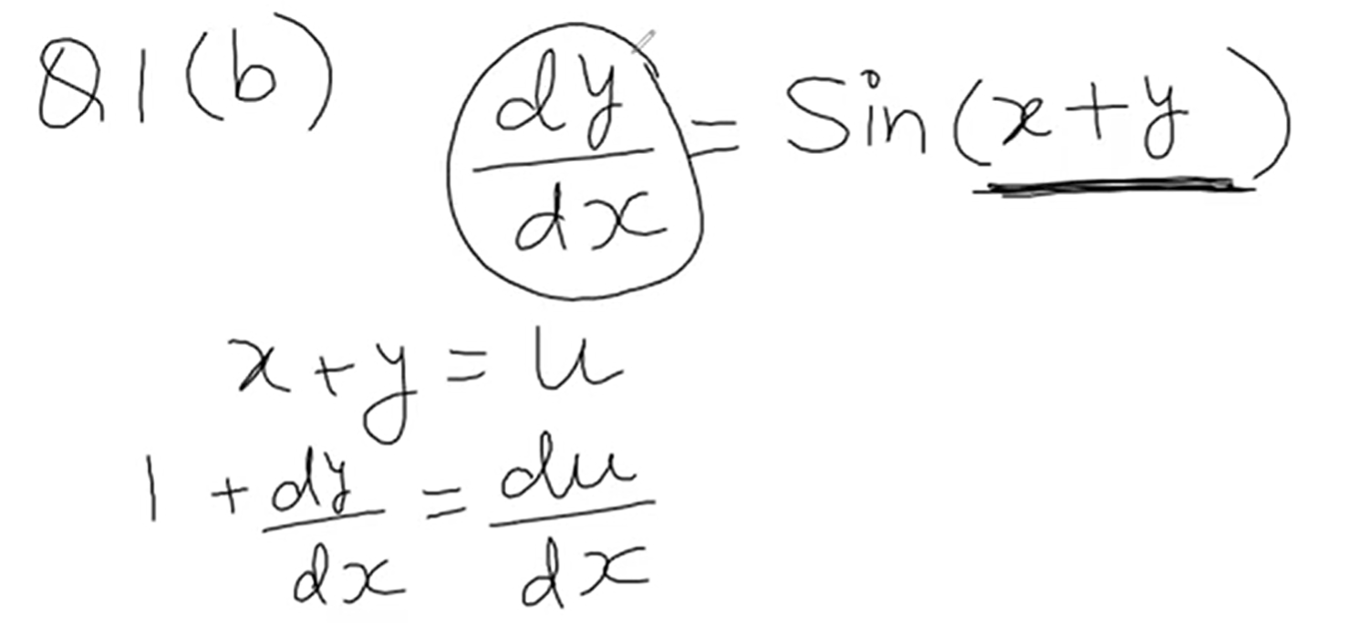

2/ Find the dy/dx

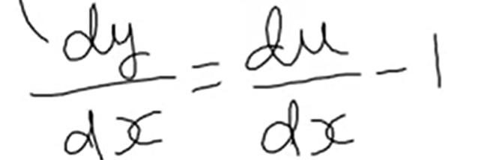

3/ Plug in the original equation and separable variables

